**Pyu inventory notes#5 Revised 20150813**

013 Terracotta votive tablet. 3 lines.

ASI 1909-10, 123 ✔

122 and on to p. 123 = Notes by Taw Sein Ko under the heading of “terra-cotta votive tablets”: “The reverse face of figs. 11 [*both faces, JKW*] and 12 [*obverse, JKW*] as well as two bricks (figs. 17 and 18 of the same plate *[=XLIX, JKW*]) are inscribed with letters in an unknown script (Fn.3)”. (Fn. 3 makes reference to de Beylié, p. 89, fig. 62 = 014.) Fig.11 shows both sides in a smaller reproduction, the reverse with three lines of Pyu (= 013). Fig. 13, the reverse of fig. 12, shows 1 line of Pyu (=014).

Mya 1961, II, 23 ✔

23: Pls. 34, 35. Three lines of Pyu on the back, beginning with ƀaṁḥ. Fig. 35 showing the inscription is definitely the same as ASI fig. 11 (above) and Luce’s (e) transcription (below). Mya’s text from p. 23 is reproduced below – see the word “ƀaṁḥ” represented in Bs transliteration between double-quotes on line 2.

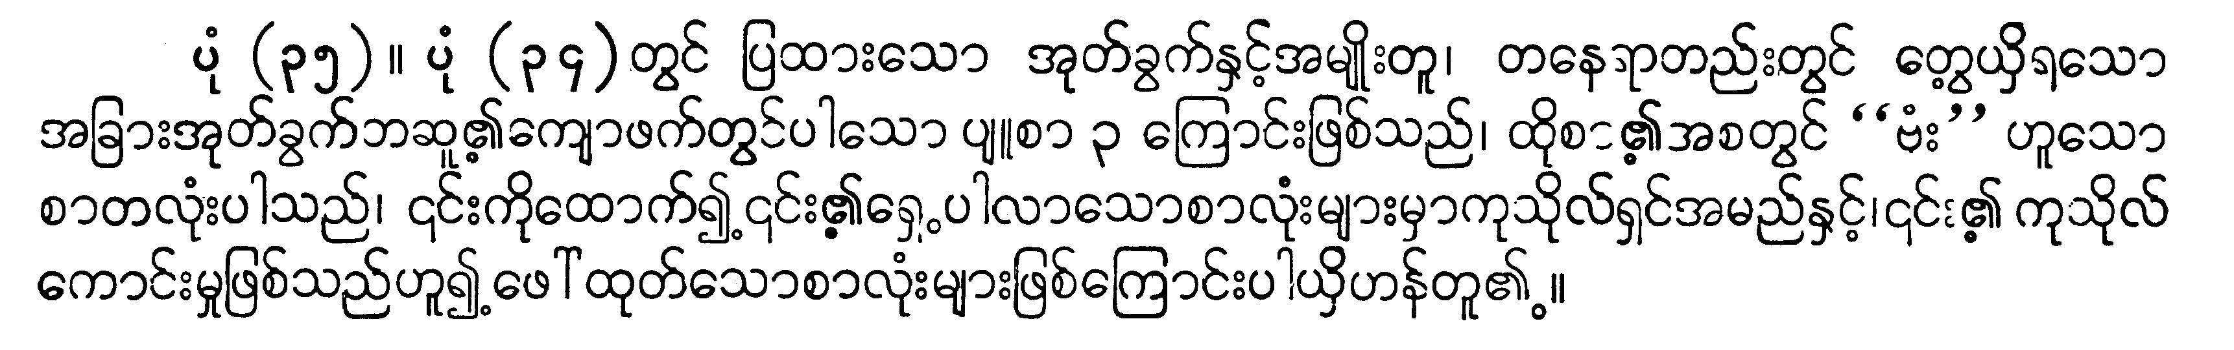

PPPB I, 152 ✔

152: [*ASI Pl. XLIX, fig. 11 is Luce’s (e) on p. 152.]* Under the heading of “Pl. 56, Sri Ksetra votive tablets”, item (e), i.e., pl. 56(e): “Another specimen (Arch. Neg. 807), showing three short lines of Pyu writing on reverse. Tentative reading [in AG transcription]: ||| ƀaṁḥ de / sa uttra pa / kƀiṁḥ co.” This matches – as near as I can tell – the script shown on fig. 11 in ASI and Mya’s Pl. 35.

QED: 013 and line 81 are citing the same inscription.

014 Terracotta votive tablet. 1 line.

ASI 1909-10, 123 ✔

122 and on to p. 123: Notes by Taw Sein Ko under the heading of “terra-cotta votive tablets”: “The reverse face of figs. 11 and 12 as well as two bricks (figs. 17 and 18 of the same plate [=XLIX]) are inscribed with letters in an unknown script”. (Fn. 3 makes reference to de Beylié, p. 89, fig. 62.) Fig. 11 shows both sides in a smaller reproduction), the reverse with three lines of Pyu (= 013). Fig. 13, the reverse of fig. 12, shows 1 line of Pyu (=014), which matches the inscription in De Beylié 1907a, 89 fig. 62, as well as Mya 1961, II, pl. 60 (gha) and PPPB II, 59 (f).

Mya 1961, II, 60 (gh) and p. 31

Pl. 60 shows the reverse inscription (59 is the obverse); a transliteration in Bs script is given on p. 31 (below – it’s the last of the four = gha).

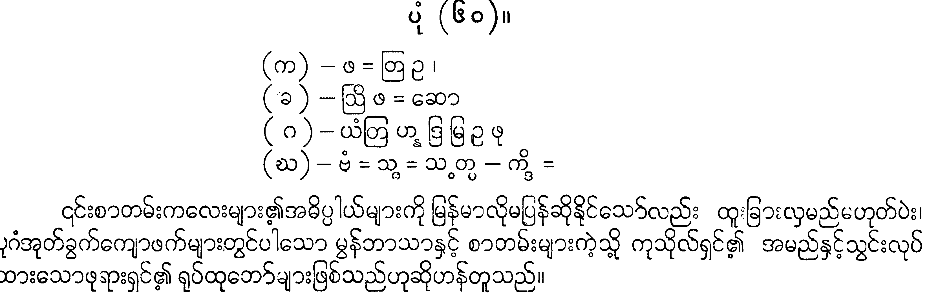

PPPB I, 155

155: Under the heading of Pl. 60 “Sri Ksetra votive tablets”: (f) “Pyu writing (not so clear) on reverses of similar pointed oval tablets from Lemyethna pagoda [AG transliteration]: ƀaṁḥ sguḥ sa paṁ kdiḥ (?).” Luce cites ASI 1910, pl. XLIX (12,13) and de Beylie, Pl. V fig. 3 (which is a different tablet); p. 89, fig. 62; p. 246, fig. 199.

Column I:

De Beylié 1907a, 89 fig. 62

Fig. 62 reproduces – by eye-drawing – the inscription shown in ASI fig. 13 above, that is, the one line inscription (5-6 akshara). Not pl. V(3), obverse only, which is a similar looking votive tablet, but whose shape doesn’t quite match.

1907b, 246 fig. 199 (not available yet)

ASI 1909-10, pl. XLIX (12, 13)

Mya 1961, II, pl. 60 (gha)

PPPB II, 59 (f).

QED: 014 and line 89 are citing the same inscription.

015 Terracotta votive tablet. 3 lines.

ASI 1910-11, 93 ✔

93: Taw Sein Ko’s comments: “… a clay tablet measuring 5”x5½” on which a Buddha figure is shown seated in the darmacakramudrā; on the reverse is an inscription (fig. 21) believed to be in Pyu, ….” Fig. 21 at the bottom right of Pl. 47 shows a clear three-line inscription, obscured in parts by a break across the middle and missing the right-hand parts of the first and second lines.

PPPB I, 158 ✔

Annotations for Pl. 62 figures. The relevant entry is (d, e), p.158: “Broken tablet, flattened at base and arching. From Tawateintha pagoda [the Tawateintha at Myanaung, on the Irrawaddy, south of Prome?]. With Pyu writing on the reverse….” Tentative reading given: < ƀå: ƀūddha tda …., etc.> (Luce writes <ƀūdhda> in error.) Pl. 62 (e) shows script (clear but fragmentary) on the reverse side.

*Note:*

*I have not been able to find reference to this in U Mya I or II – certainly not in the illustrations. Curious - I would have expected it to be there.*